
The meeting of Satterthwaite Parish Council to be held in the Parish Room, Satterthwaite on Monday 8th June 2026 at 7.30 pm for the purpose of transacting the business outlined in the agenda below.
Agenda
Item |  | Additional  information
Opening Administration
1 | Welcome and Introductions  Apologies  Emma Nield
2 | Declarations of interest  - To receive declarations by elected and co-opted members of disclosable pecuniary interests in respect of items on this agenda
3 | Requests for Dispensations  - The clerk to report any requests received since the previous meeting for dispensations to speak and/or vote on any matter where a member has a disclosable pecuniary interest.
4 | Minutes  - To authorise the Chair to review and sign last meetings minutes on 20th April 2026 | Minutes attached from 20th April 2026
Matters for consideration
5 | Public participation  - To receive comments and representations from members of the public in relation to any item on the agenda
6 | Updates on ongoing issues and actions from last meeting  Review of action log  - Playground quotes – 3 companies contacted:  - Flights of Fantasy Teams 1st May  - Pentangon play face to face 7th May  - Playdale face to face 4th June  - Zurich insurance – policy updated - action complete  - Village Parking progress - awaiting LDNPA response  - Moor lane and motorcyclists  - Fibrus complaint meeting  - Community Governance response – completed – awaiting result  - AGAR return – to be approved/signed – see item 7  - Home to school transport consultation – response sent raising concerns - complete | Action log
7 | Items for meeting not covered above  AGAR – to approve/sign  Exercise of public rights – to set dates
8 | Additional or urgent points to raise regarding Parish or Councillor matters
9 | Items for the Lengthsman
Planning
10 | Planning Consultations sought from Parish Council  - 7/2025/5659 - 1-5 Force Forge Cottages Septic tank upgrade – granted  - 7/2026/5171 - YMCA Training Centre – replacement of jetty – granted  - 7/2026/5047 - Installation of solar mounted solar system - granted
Finance
11 | Accounts since last meeting  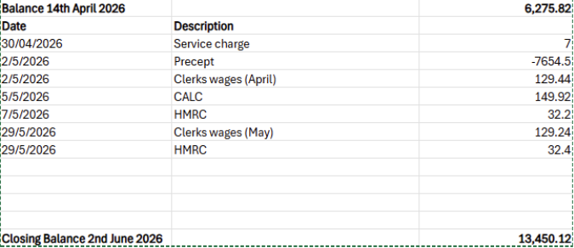
12 | Review 26/27 year budget – revised – matching amounts from previous year
  Outgoings 25/26 |  |  | Proposed budget 26/27
  Clerks wages | 1714.27 |  | Clerks wages | 1553.28
  HMRC | 411.6 |  | HMRC | 400
  Unity service charge | 72 |  | Unity service charge | 84
  Games night | 106 |  | Games night | 106
  Gritting | 500 |  | Gritting | 300
  Lengsthman | 1412 |  | Lengsthman | 1400
  Room hire | 57 |  | Room hire | 60
  CALC - fee | 145.58 |  | CALC - fee | 149.92
  CALC training | 100 |  | CALC training | 100
  Zurich | 194.25 |  | Zurich | 194.25
  Payroll | 144 |  | Payroll | 144
  Heartbeat Trust | 223.2 |  | Heartbeat Trust | 223.2
  Petty cash | 100 |  | Petty cash | 100
  Other (non-recurring maintenance etc) | 2647.92 |  | Other (non-recurring maintenance etc) | 1500
   | 7827.82 |  |  | 6314.65
   |  |  | Precept | 7654.5
   |  |  | Reserves | 1339.85
Key correspondence, consultations and reports not covered above
13 | Wings over Windermere Exemption Request Consultation – ends 25th June
14 | Parkamoor Workshop Rusland Reading Rooms - 8th June
15 | Windermere Marathon 2026 – 14th June – Temporary Traffic Regulation Order
Council calendar
Closing administration
16 | Agenda items for next meeting
17 | Next meeting date to be agreed  July 13th 7:30pm Satterthwaite Parish Room

